TRADER (PHP)

1. First, you will need to go to the homepage of Food Galore and then you can click on the account button, which is on right side of the navigation bar.



1. To register as a trader you will need to fill the form. Your password must contains one capital letter, small letter, one numeric key and one special character. The email address must not be repeated. After filling the form click on signup button.

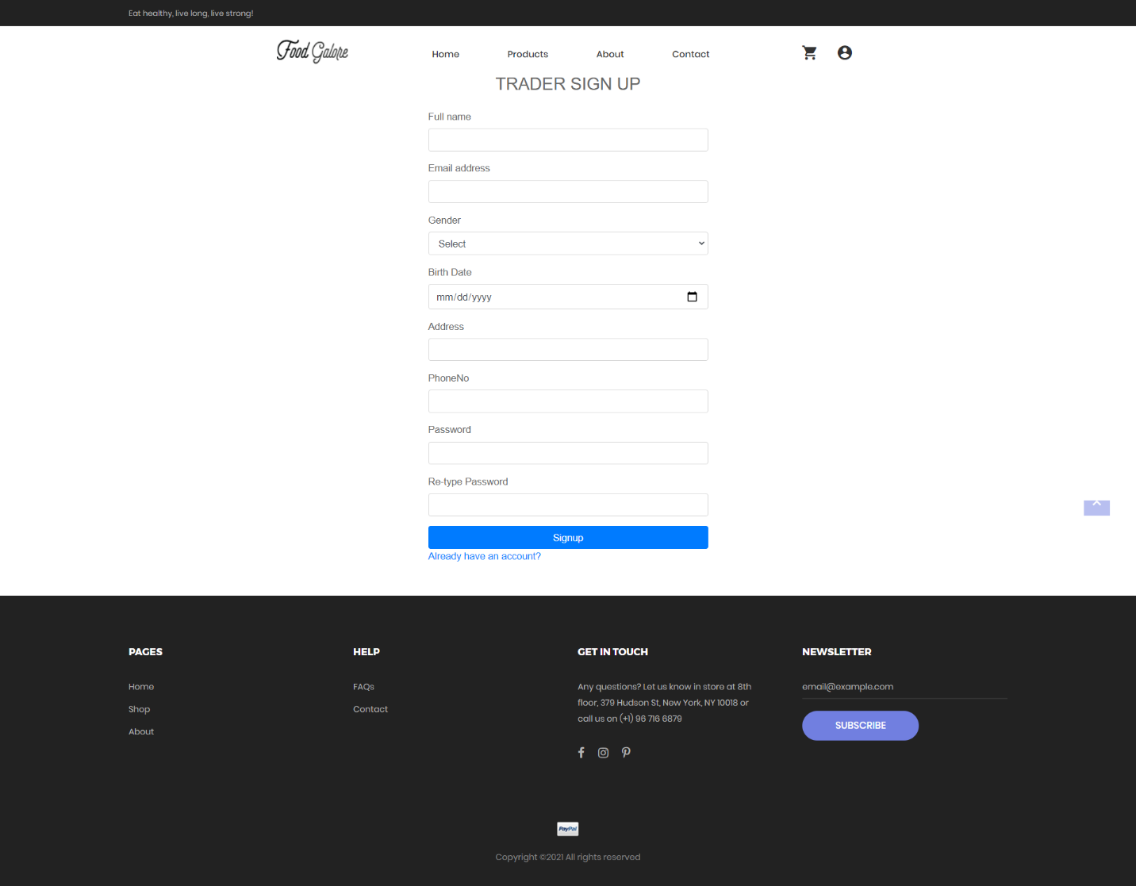

1. After signing up you will get OTP in your email address. Enter the OTP provided by admin in the form.

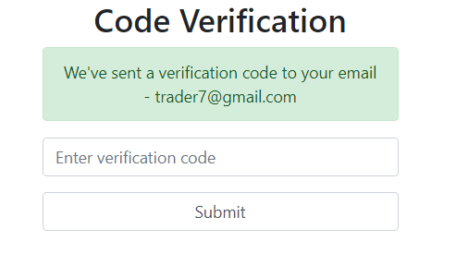

1. After verifying through OTP confirmation, the trader should login.

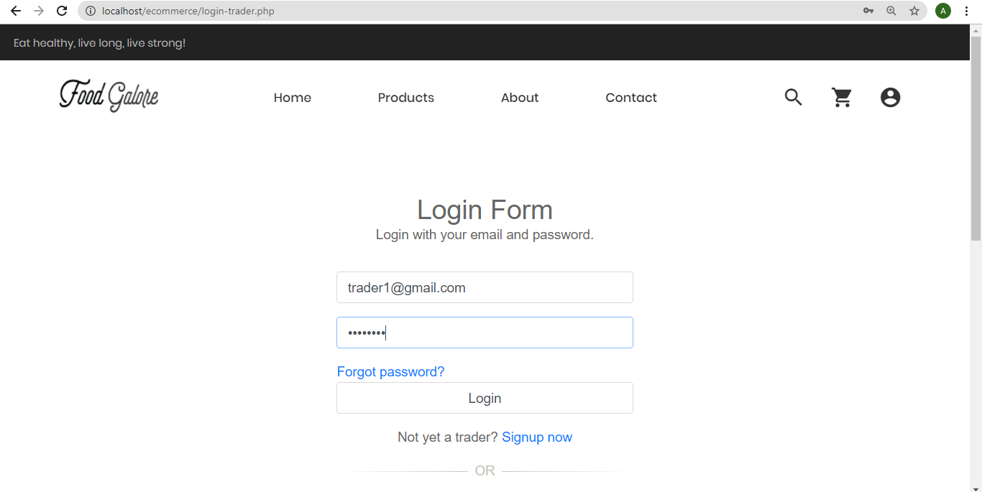

1. After logging in, the trader can add shop and products in their respective shops. To add shop click on Shops that is on the left side. Enter the shop name and image link of the shop. Traders are only allowed to add two shops.

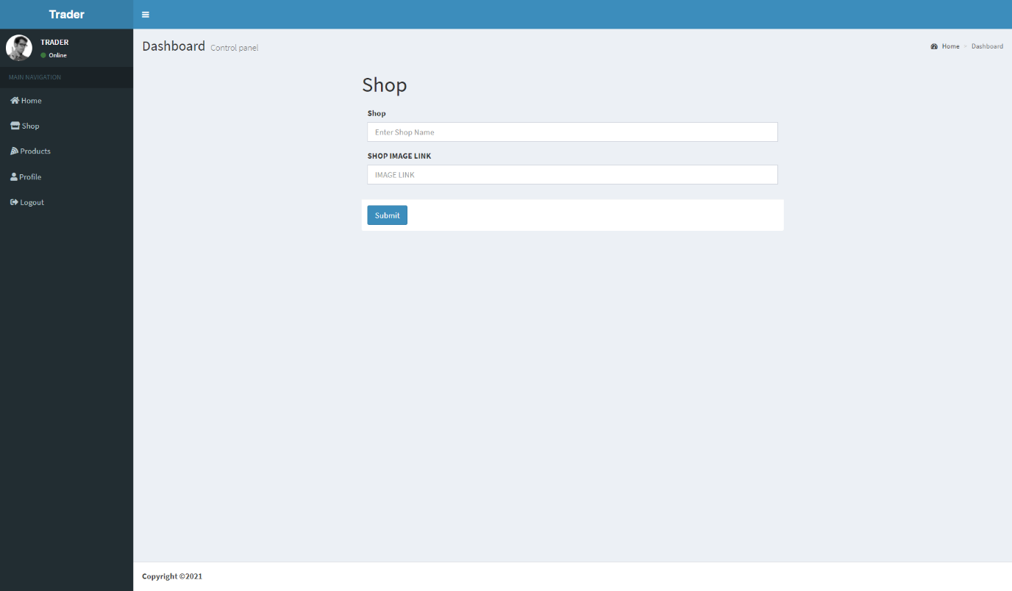

1. To add the products in the shop, click on products that is on the Products that is on the left side. Fill the form and after filling it click on Submit button.

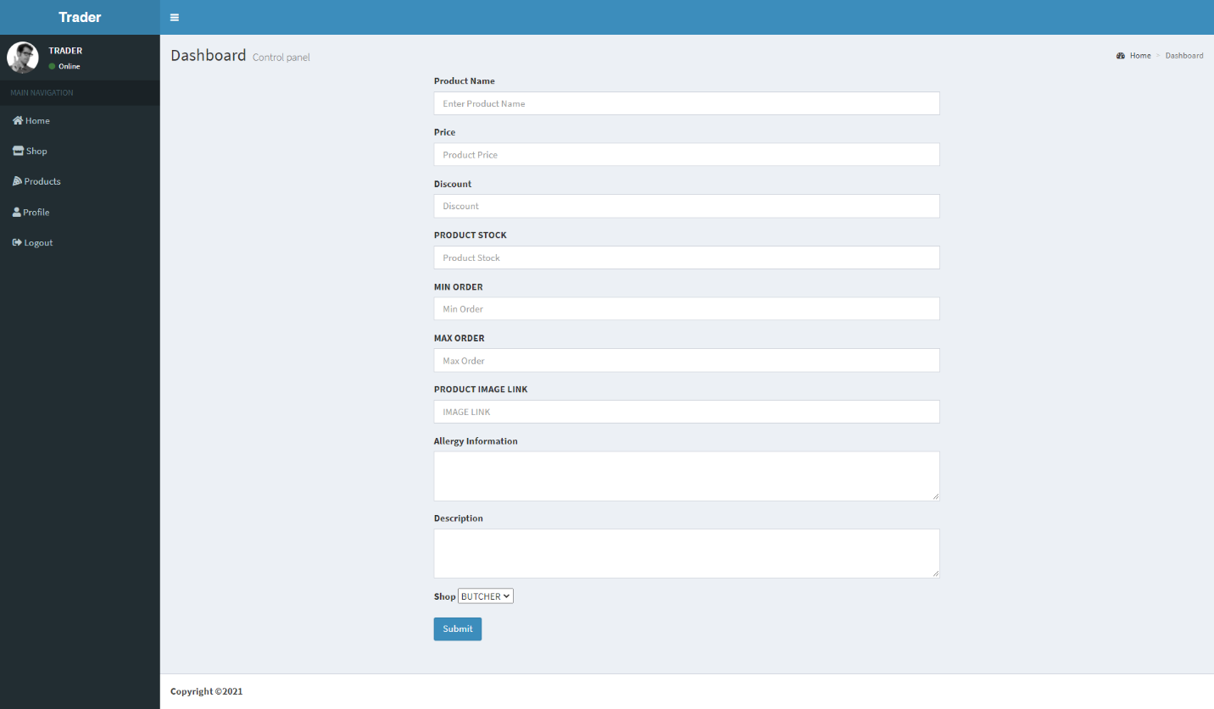

1. Once the correct trader login credentials are filled, you will see a page with dashboard . You can also update your Shop Details, Personal Details as well as Contact Details.

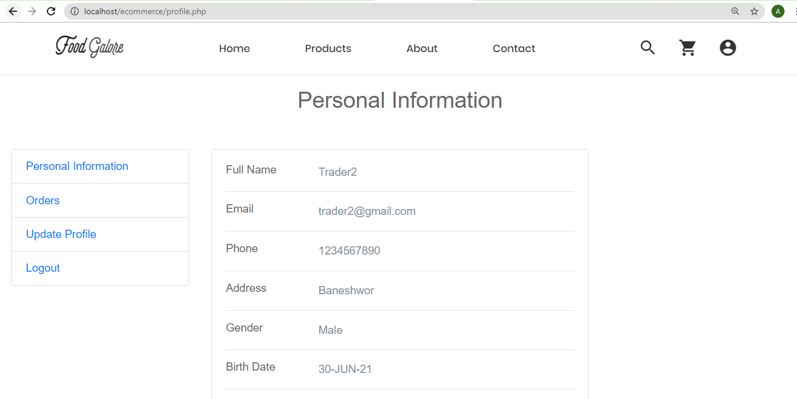

1. If you click on Update/Delete Shop Details option, it will allow you to view all the shop with their details. You can update or Delete Products. If you want to add new shop then click on add new button.

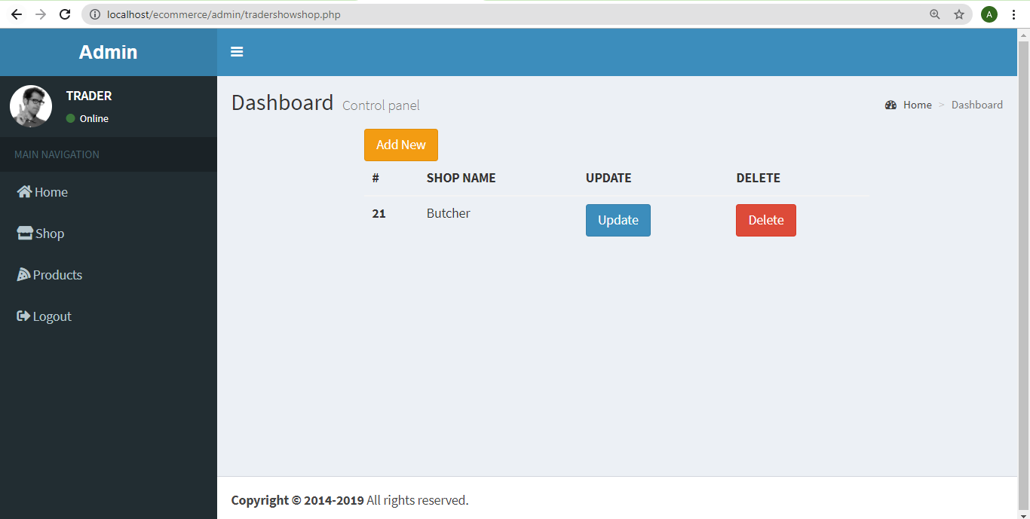

1. If you click on Update/Delete Product Details option, it will allow you to view all the product with their details. You can update or Delete Products. If you want to add new product then click on add new button.

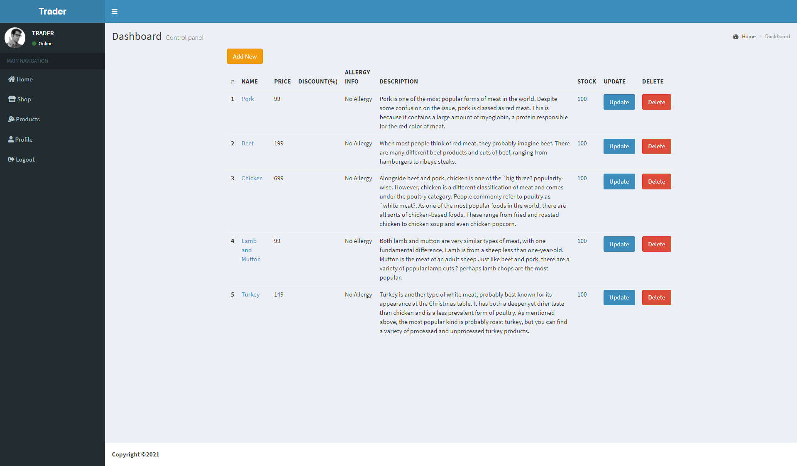

1. To logout, click on logout that is on the left side.

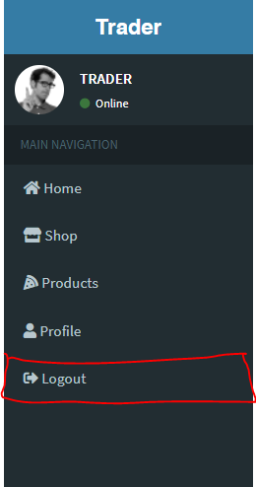

1. If you forgot password then click on forgot password and reset your password.

